Problem-Solving Studio 3B – Blood Flow through the heart, Cardiac Cell Excitability Mechanisms, EKG Data Analysis
BMED 3100
March 10, 2025
Group Number: _____
Names: _______________________________________________________________________
Objectives:
- Understand how clinicians perform disease diagnosis via ECG.
- Evaluate accuracy of Machine learning models to diagnosis cardiac events via ECG
- Understand pros and cons of large data and visual approaches to cardiac disease diagnosis
- Analyze the impact of mitral valve disease and atrial fibrillation on cardiac function and circulation.
- Compare the excitability mechanisms of pacemaker and contractile cardiac cells and evaluate how medications (metoprolol, digoxin) and pacemakers regulate heart rate in a patient with atrial fibrillation and bradycardia.
- Interpret an electrocardiogram (EKG) of atrial fibrillation and explain why a pacemaker does not restore normal atrial contraction, reinforcing the relationship between electrical activity, autonomic regulation, and cardiac output.

Case 15-2018: An 83-Year-Old Woman with Nausea, Vomiting, and Confusion Melissa L.P. Mattison, M.D., Victorine V. Muse, M.D., Leigh H. Simmons, M.D., Christopher Newton‑Cheh, M.D., M.P.H., and Rory K. Crotty, M.B., B.Ch., B.A.O.
An 83-year-old woman was admitted to the hospital during the winter with symptoms of nausea, vomiting, confusion, and weakness. One week before admission, she had developed a runny nose, sore throat, and a nonproductive cough but did not report any fever. Two days before admission, she began experiencing nausea, vomiting, and diarrhea. By the following day, her daughter noticed that she was asking repetitive questions and failing to recognize family members. On the day of admission, she reported feeling globally weak, prompting her daughter to bring her to the emergency department for evaluation.
The patient had a history of rheumatic heart disease, a chronic heart condition that develops as a complication of rheumatic fever and had undergone mitral valve replacement and tricuspid valve repair. She also had a permanent ventricular single chamber pacemaker, an electronic device that controls the heartbeat pacing by connecting the lead to the right ventricle, due to persistent bradycardia. Her cardiovascular conditions included a narrowing (stenosis) of the mitral valve, which makes it harder for blood to flow forward, and a leaking (regurgitation) mitral valve, which allows some blood to flow backward instead of moving in the right direction. In addition to atrial fibrillation, which resulted in an irregular and uncoordinated atrial contraction. On examination, her blood pressure was 153/60 mmHg, her pulse was 64 beats per minute, and her respiratory rate was 18 breaths per minute. She looked extremely thin and weak, seemed very tired, and gave confused or nonsensical answers to questions. An electrocardiogram (EKG) revealed an absence of distinct P waves, confirming the presence of atrial fibrillation. Despite having a pacemaker, her atria continued to fibrillate.
Her medical regimen included furosemide, a diuretic used to manage fluid retention; metoprolol, a beta-blocker to control heart rate; digoxin, a drug that enhances acetylcholine release from the vagal nerve that is part of the parasympathetic system that innervates the heart; and warfarin, an anticoagulant to reduce the risk of clot formation. Given her history of mitral valve disease and atrial fibrillation, her symptoms of weakness and confusion raised concerns about possible complications related to her cardiac condition.

Problems:
Zip file of Matlab materials: BMED3100_PSS
Spreadsheet to share class results: ECG Classification PSS Fall 2025.xlsx
1. One of the first tests administered to the patient was an electrocardiogram (ECG). Pretend you are an ER resident. An ER attending physician (your boss) reports that the patient is NOT in atrial fibrillation (A-Fib), but you disagree.
  - Only one person from your group needs to run the provided Matlab code, but each group member is welcome to run the code on their personal laptop. Ensure you have Matlab 2023, 2024, or 2025 with the Statistics and Machine Learning AND the Signal Processing Toolboxes installed.

  - Download the Matlab files from the link files above. Find it on your computer, unzip the folder, and then from within that folder open the file: BMED3100_ECG_PSS_compressed.mlx

  - Examine the following ECG and annotate it, i.e. mark the features that you think could indicate the patient is in A-Fib.
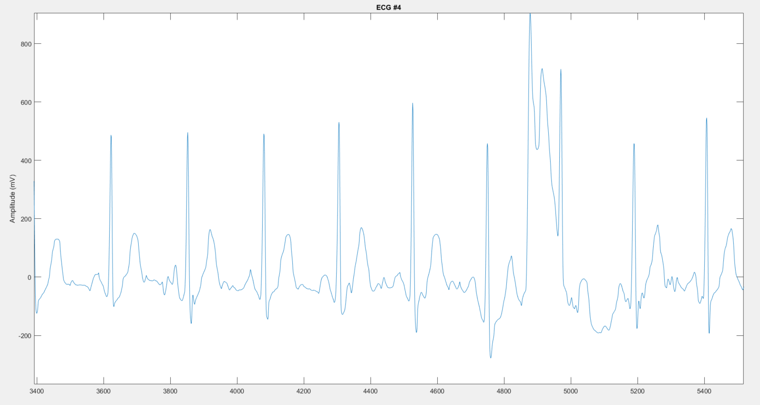

  - Run SECTION 1 of the Matlab code (read the instructions in Matlab carefully). When it is done running you will see displayed at the bottom of SECTION 1 (not in the command window) two ECGs that are the same for everyone in the class (#4 and #1) and one random ECG that is different for each team. Look at the signals and decide whether you think each is an A-Fib signal and why. Enter those decisions in the spreadsheet you were sent the link to. [Completion grade only]
When you are done, as a team discuss the questions below. As everyone finishes, you will discuss them as a class:
  - Were your diagnoses correct? (The correct classification for ECGs 4 and 1 will be discussed as a class.) [Completion grade only]
#4 is A-fib and #1 is not
These ECGs are part of the KEY ONLY
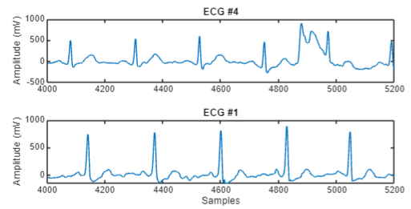

    - What did you see in the plots that led you to make the choice you did? [Completion grade only]
In class, students can discuss things like the T-P segment being non-flat indicating abnormal electrical signaling before the P wave (atrial depolarization). This can also lead to a review of the parts of an ECG if they don’t really know what to look for.
Students could be considering the P-R interval, the time it takes for SA node signal to get to AV node. This isn’t directly relevant to A-fib.

    - Why does A-Fib result in the changes you indicated in part 1A to the ECG signals? [graded]
Since atrial fibrillation results in disorganized atrial contractions, there would be a reduced or absent P wave that corresponds to the atrial cells not depolarizing all at the same time. In general, abnormalities prior to the QRS complex would be visible.

    - What was challenging about making the diagnoses? [Completion grade only]
Run section 2 of the Matlab code. There are two options. If you have Matlab 2024 – run section 2A. If you have Matlab 2023, run Section 2B. Your version of Matlab can be found in the the very top left of your Matlab window, by the Matlab icon. Once your code is running, continue reading.
Interestingly, ECGs are not something that even cardiologists are 100% accurate at analyzing. With the increasing prevalence of AI prediction tools, hospitals would be interested in a tool that can accurately, with low false positives and low false negatives, predict A-Fib. We trained a deep learning model on about 8000 ECG signals. Training means the model learned what to look for in ECGs to best predict A-Fib/not A-Fib. When it was done training, we calculated the accuracy of the classification – meaning for the data it used to learn to classify A-Fib/not how accurate is the model.
Overall, the model had 87% accuracy at correctly classifying the data it was trained on. A confusion chart (see below) showed that model correctly classified A-Fib 3738 times, misdiagnosed A-Fib as NOT A-Fib 280 times, and misclassified NOT A-Fib as A-Fib 734 times.
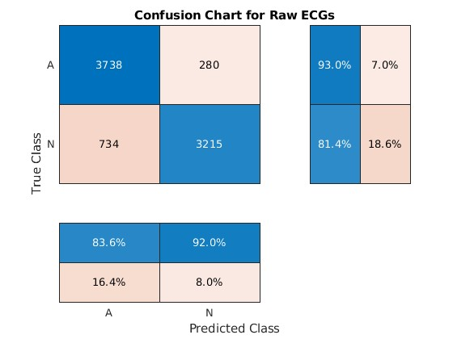
Your job is to test the model that we trained on ECG data the model has never seen before. That is, you get to use it for inference – meaning to look at a new signal and classify it as A-Fib/not A-Fib. The code in Section 2 does the inference step on 998 new ECG signals that the model has never seen before. That allows us to test the accuracy of our model.
While the code is running, (between 2 and 5 minutes), start working on the problems below (f - i).
  - Why might a raw ECG signal be challenging to fit to a mathematical model? [Completion grade only]

Students may be confused by the non-specificity of this question. There are some things about ECGs that are “easy” to quantify (peak-to-peak interval for example = HR). Raw ECG signals (in the time domain) may be harder to fit compared to changing them to the frequency domain instead. Other examples...
A raw ECG signal has many potential issues – noisy signal (bad electrode placement?), etc. Students should identify one or more relevant issues.

  - Enter the data from Section 2 of the code into the spreadsheet. You should enter the time it took to run (inference_time), the overall accuracy (Test_Accuracy) and the true positives, false positives, true negatives, and false negatives from the “confusion chart” that prints below Section 2. What do you think about the accuracy of this model for diagnosing AFib in clinical settings? [Completion grade only]
  - What do you notice about the test accuracy you just calculated when you compare it to the training accuracy we presented above? [completion grade only]

Now run section 3 of the code
The first model we trained to classify ECGs as having A-Fib or not did so by looking at raw ECGs, i.e., the electrical signal data itself. As you just found, the model worked alright (~87% accurate) on the training data, but from when tested against a new set of data, the accuracy was much lower. We trained a second model using a technique called feature extraction to try and improve the accuracy of our classification tool.
Feature extraction takes raw data and processes it to make it easier for the neural network to understand. In this case, we used things that you know about the heart, heart rhythms, and ECG signals to do that. Specifically, we converted the ECGs from the time domain to the frequency domain. We did that using three signals analysis tools: a power spectrum, instantaneous frequency, and spectral entropy. Instantaneous frequency is the frequency of a given signal at any point in time. While some signals have a constant frequency (e.g., a sine wave), sometimes the way in which a signal changes frequency can provide useful information about what is happening in it. Spectral entropy quantifies the disorder or complexity of a signal. Signals with more spectral entropy have more randomness than those with less (i.e., their energy is spread more evenly across the frequency domain). As with instantaneous frequency, differences in spectral entropy can provide insights that looking at the raw signal cannot. We extracted instantaneous frequency and spectral entropy from each ECG in our dataset and used those features to train the second model.
  - Section 3 of the code will produce three pairs of charts, one for power spectrum, one for instantaneous frequency, and one for spectral entropy. For each pair, an ECG without A-Fib is plotted first and an ECG with A-Fib is plotted second. Looking at each pair of graphs, please try and describe the differences between A-Fib and not A-Fib that you see. [completion grade only]
Now run section 4 (either 4a or 4b depending on your Matlab version)
  - Enter the same results (time, accuracy, True positive, etc.) as you did for the first model into the spreadsheet starting in column R. [completion grade only]
The accuracy of the feature extracted model during training was 95%. Compare your test data accuracy to the training data accuracy and provide your thoughts on this model. Is it better for clinicians to use this model even if the signals it is trained on are harder to interpret by human eye? [completion grade only]

  - As an ER resident, you make the decision to treat the patient in the case study as if she is in A-Fib by administering metropol, a beta-1-blocker. Beta-1 blockers work by reducing the heart rate and decreasing the force of contraction. Would metoprolol affect A-Fib? Would shocking the patient with an external defibrillator fix A-Fib? An external defibrillator is a synchronized shock that can be applied to a patient. Explain why.
Template Answers
Beta 1 blockers work by reducing the heart rate and decreasing the force of contraction, which helps control the ventricular rate in A-Fib. By blocking beta-1 adrenergic receptors in the heart, metoprolol slows down the transmission of electrical impulses through the AV node, which is crucial for rate control in patients with A-Fib. However, metoprolol does not directly convert A-Fib into normal sinus rhythm; it primarily helps to manage symptoms by preventing rapid heart rates.
Shocking a patient with an external defibrillator can potentially "fix" A-Fib. It works by resetting the heart's electrical activity, allowing the sinus node to resume its normal pacemaking function.

  - If you had decided that the patient was not in A-Fib but she actually was (a false negative), what would be the consequences of untreated A-Fib in terms of blood pressure?
Template ans: Failing to diagnose A-Fib leads to unmanaged irregular heart rhythms, putting the patient at risk for both short-term blood pressure variability and long-term chronic hypertension. These complications can further progress to heart failure and increase the risk of systemic events such as stroke.

Section 2: Establish Foundational Knowledge to Clarify Misconceptions
2a. Blood Flow Through the Heart:
i. The patient has mitral valve stenosis (narrowing of the mitral valve) and mitral valve regurgitation (leaking of blood backward through the valve). Explain what happens during valvular stenosis and regurgitation and how it impacts the blood flow.
Template Ans:
Valvular stenosis is when the valve leaflets are hardened (possibly due to calcification of the leaflets) and do not open properly narrowing the opening of the valve. This restricts the blood flow in the next chamber.
Regurgitation is when the valve doesn’t close properly, becomes leaky and allow the backward flow of blood
ii. Which heart chamber would experience increased pressure due to mitral valve stenosis, and how could this lead to lung-related symptoms such as shortness of breath?
Template Answer:
Mitral valve stenosis causes increased pressure in the left atrium because blood has difficulty moving into the left ventricle.
This pressure backs up into the lungs, causing pulmonary hypertension, fluid buildup, and symptoms like shortness of breath and fatigue.
Over time, right heart strain can develop because the right ventricle has to work harder to pump blood into the lungs.
TAs: look out for these common Misconceptions:
The left ventricle has increased pressure. (Incorrect—left ventricle receives less blood.)
Blood backs up into the body. (This happens in right-sided heart failure, not mitral stenosis alone.)

2b. Cardiac Cell Excitability Mechanisms (Conducting vs. Contractile Cells)
The patient has a pacemaker because of a slow heart rate (bradycardia) caused by atrial fibrillation. What is the main difference between the action potentials in pacemaker cells (which control heart rhythm) and contractile cardiac cells (which cause the heart to pump)? Hint: draw the action potential graphs for both cell types: indicate the different ion channels and phases
Template Answer:
Nodal Cells Contractile Cells
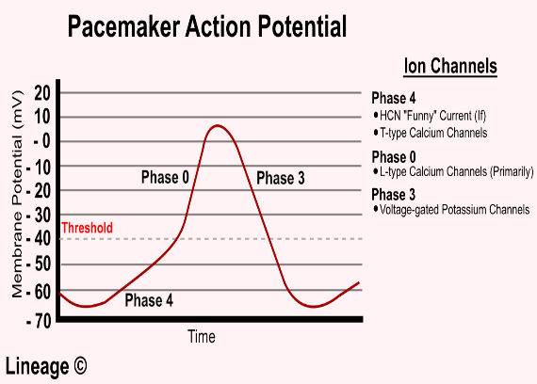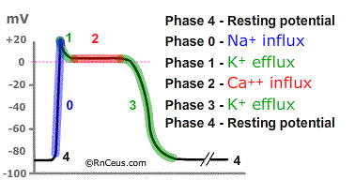
Cardiac Cell Excitability Mechanisms:
Pacemaker cells (SA node & AV node): a. Depolarize on their own (spontaneous action potentials).
b. Have no stable resting potential; c. Relies on Funny Na+ channels and Ca2+ channels for depolarization.
Contractile cells (Atria & Ventricles): a. Require a stimulus (they don’t fire on their own); b. Have a stable resting membrane potential; c. Depolarization relies on Na+ influx, Ca2+ plateau, and K+ repolarization.
i. Why might a pacemaker device be necessary in a patient with atrial fibrillation?
Template Answer:
A pacemaker device is needed because atrial fibrillation can prevent proper AV node function, leading to slow ventricular contraction (bradycardia).
TAs: Common Misconceptions:
Pacemaker cells contract the heart. (They generate rhythm but do not contract.)
A pacemaker cures atrial fibrillation." (It controls ventricular rate, not atrial function.)
i. Why doesn’t a single chamber ventricular pacemaker always restore a normal P wave pattern in a patient with atrial fibrillation?
Template Answer:
Ventricular Pacemakers don’t restore a normal P wave because the pacemaker controls the ventricles, not the atria. The atria are still fibrillating, so the electrical activity remains chaotic.
TAs Common Misconceptions:
"A pacemaker fixes AFib completely." (No, it just controls the ventricular rate.)
"A pacemaker will always create spikes on the EKG." (Some pacemakers only activate when needed.)
Section 3: Using Foundational Knowledge to Solve Problems
3a. The patient has mitral valve stenosis and regurgitation. How would this condition affect the right ventricular function over time? Would you expect the patient to develop right-sided heart failure? Why or why not?
Template Answer:
-Mitral valve stenosis increases left atrial pressure, causing pulmonary hypertension as pressure backs up into the lungs.
-Over time, the right ventricle must pump against increased resistance in the pulmonary circuit, leading to right ventricular hypertrophy and potential failure.
-Yes, right-sided heart failure can develop, leading to systemic congestion, fluid retention, and peripheral edema.
TAs: Common Misconceptions:
"Mitral valve disease directly causes right-sided heart failure." (The failure is indirect, due to pulmonary hypertension.)
"Only the left heart is affected." (The right ventricle compensates, but chronic strain leads to dysfunction.)

3b. The patient has a history of mitral valve disease and atrial fibrillation. Her blood pressure is 153/60 mmHg, which is different from the typical reference value (~120/80 mmHg).
Note: Blood pressure is the force that blood applies to the walls of blood vessels as it moves through the body’s blood vessels. Every time the heart contracts (beats), it pushes blood out into the arteries, creating higher pressure (systolic pressure, top value). Between beats, when the heart relaxes and fills with blood, the pressure in the arteries drops (diastolic pressure, bottom value).
Blood pressure changes depending on how much blood the heart pushes out and how easily blood flows through the blood vessels.
Based on this, do you expect her systolic and diastolic blood pressures to be higher or lower than normal?
Mitral valve regurgitation: (leave in blank)
Template Answer:
Mitral regurgitation means that some of the blood that should move forward into the aorta leaks backward into the left atrium.
This reduces how much blood is ejected into the aorta, which you might expect to lower blood pressure.
Atrial fibrillation: (leave in blank)
Template Answer:
Atrila fibrillation means the atria are not contracting effectively, so the left ventricle starts with less blood before each heartbeat.
If the ventricle starts with less blood, it can’t push as much forward, which also suggests a lower blood pressure.
3c. Are your predictions correct compared to the patient’s blood pressure? If not, explain plausible reasons why.
Systolic Pressure (top number of 153/60 mmHg, reference values 120/80 mmHg) (keep in blank)
Template Answer:
Prediction is incorrect b/c the patient’s systolic blood pressure is higher than expected (153 mmHg instead of ~120 mmHg).
Plausible reason: In response to less effective blood ejection from the left ventricle, the arteries may tighten (vasoconstriction) to push blood forward more forcefully. This will decrease the space in the blood vessels and therefore increase the pressure.
This raises systolic pressure, even though the actual amount of blood being pumped may be lower than normal.
Diastolic Pressure (bottom number of 153/60 mmHg, reference values 120/80 mmHg) (keep in blank)
Template Answer:
Less blood is staying in the arteries between beats.
Mitral regurgitation means blood is leaking backward into the left atrium instead of staying in circulation.
This reduces the total blood volume moving through the arteries, so there’s less blood to maintain pressure when the heart is relaxed.
TAs: Suggestions on how to help learners arrive at this conclusion:
If students struggle, try guiding questions like:
“If blood is leaking backward into the left atrium, what happens to the total amount of blood staying in the arteries?”
Expected answer: It’s less than normal.
Follow-up: Right! If less blood stays in circulation, pressure between beats will drop.
“If the atria aren’t pumping effectively, will the left ventricle start with more or less blood before it contracts?”
Expected answer: Less blood.
Follow-up: Yes! If the ventricle starts with less, it can’t send as much forward, which affects blood pressure.
4. Concept Map: Connecting all the dots!
Create a concept map that visually organizes how the patient's mitral valve disease, atrial fibrillation, and pacemaker influence blood flow, cardiac excitability, and EKG findings. Hint: Place the patient’s condition as the central node then create three major branches: Blood Flow & Hemodynamics; Cardiac Excitability; EKG Findings & Pacemaker Function.
(Reviewing TA: please create concept map key and place here)

5. Now go back and take a look at the class data from the AFib AI/ML model on the class Spreadsheet. Use it to discuss/answer the questions below. Look at two sheets: The Manual Diagnostics Summary sheet shows how well you and your classmates did at evaluating ECGs for AFib. The Neural Network Accuracy Summary sheet shows how the AI tool did at classifying ECG signals. [All completion grade only]
- Based on the accuracy of the class (Manual) diagnosis and the accuracy of the AI tool (Neural Network), how would a positive diagnosis of A-Fib from either your classmate or from the AI tool affect the treatment you would give the patient?
- How does the accuracy of the AI tool compare to different levels of doctor (Manual). How does that affect your evaluation of the accuracy of the AI tool?
- How is B. affected by the inference time it takes the AI tool to interpret one ECG?
- Based on what you have seen today, what role do you think AI/ML has in diagnosing cardiac measures (ECGs, blood pressure, patient symptoms, medical records, etc.) now and in the future?

- What is one thing about this entire PSS that your group is struggling with or confused by?
TAs: Please do not place this in any key or blanks. This is only here for analysis.

Bloom’s Taxonomy Analysis of PSS 3A Questions
Question | Bloom’s Level | Cognitive Skill Targeted
1a. What are the primary functions of ADH, and what physiological stimuli lead to its release? | Understanding (L2) | Recall & comprehension of ADH function and regulation.
1b. What are the primary functions of ACTH, and what physiological conditions stimulate its release? | Understanding (L2) | Recall & comprehension of ACTH function and regulation.
1c. Describe the role of cortisol in homeostasis and explain how its release is regulated. | Understanding (L2) | Recall & comprehension of cortisol function and negative feedback regulation.
2a. Given the MRI findings, explain how this could lead to both central diabetes insipidus and elevated ACTH levels. | Analysis (L4) | Identifying cause-effect relationships between pituitary dysfunction, ADH deficiency, and ACTH overproduction.
2b. How would dysfunction of the HPA axis contribute to the patient’s hormonal imbalance? Predict potential complications. | Analysis (L4) → Evaluation (L5) | Evaluating system-wide effects of HPA dysfunction and predicting consequences (metabolic, cardiovascular, immune).
2d. Provide two physiological causes for the patient’s hypernatremia. How did desmopressin (DDAVP) help address this imbalance? | Application (L3) → Analysis (L4) | Applying physiological knowledge to differentiate between water loss vs. sodium retention and explaining the role of DDAVP in correcting hypernatremia.
2e. Given the X-ray findings and blood results, propose a cause for the patient’s muscle cramps and weakness. Support your answer using your knowledge of hormones. | Application (L3) → Analysis (L4) | Applying knowledge of PTH and calcium homeostasis to identify primary hyperparathyroidism as a cause.
3. Construct a concept map with 'Central Diabetes Insipidus (DI)' as the central node. Expand with supporting mechanisms and clinical consequences. | Creation (L6) | Synthesizing physiological concepts across multiple systems to establish meaningful connections.

Useful definitions of terms from part 1 of the PSS (for TAs and instructors)
Spectral entropy:
Spectral entropy is a measure used in signal processing and information theory to quantify the unpredictability or "disorder" of a signal's frequency distribution. It is derived from the concept of entropy, which is a measure of the uncertainty or randomness of a system. The idea is to calculate the entropy based on the power spectrum (or frequency distribution) of a signal. Here's how it works:
- Power Spectrum: First, the signal is transformed into the frequency domain, often using techniques like the Fast Fourier Transform (FFT). This results in a power spectrum, which shows how the signal's energy is distributed across different frequencies.
- Normalization: The power spectrum is normalized so that it represents a probability distribution. Each frequency component in the signal will then have a probability that reflects its contribution to the total energy.
- Entropy Calculation: Spectral entropy is then calculated using Shannon's entropy formula for a probability distribution:
Low spectral entropy means the signal has a dominant frequency, indicating a more ordered, less complex signal.
High spectral entropy indicates a more complex signal with a more even distribution across frequencies, suggesting more randomness or unpredictability.
Instantaneous frequency
Instantaneous frequency refers to the frequency of a signal at any given moment in time. Unlike the average frequency, which gives a constant measure over a period of time, instantaneous frequency allows you to track how the frequency of a signal evolves over time.
In more formal terms, the instantaneous frequency can be thought of as the rate of change of the phase of a signal with respect to time. In electroencephalogram (EEG) or electrocardiogram (ECG) analysis, instantaneous frequency can help identify specific patterns of neural or heart activity, which are often non-stationary.
Power Spectrum
A power spectrum is a representation of the distribution of power (or energy) of a signal across different frequencies. It is commonly used in signal processing, physics, and engineering to analyze how a signal's energy is spread across various frequency components. The power of a signal at a specific frequency is proportional to the square of its amplitude at that frequency. The higher the power at a particular frequency, the more that frequency contributes to the overall signal. In general, a spectrum refers to the range of different components (like frequency, wavelength, etc.) present in a signal. The power spectrum, specifically, focuses on how much energy is present in each frequency component. To calculate the power spectrum of a signal, you typically first transform the signal from the time domain to the frequency domain using a mathematical technique like the Fourier Transform (usually the Fast Fourier Transform (FFT) for computational efficiency). The Fourier Transform breaks the signal down into its constituent frequencies, and the resulting output gives the amplitude of the signal at each frequency. The power spectrum is then derived by squaring the amplitude of the frequency components, since power is proportional to the square of the amplitude.
Test data
Test data refers to a set of data used to evaluate the performance of a trained model. It is separate from the training data, which is used to build or "train" the model. The test data is kept aside during the training process to ensure that the model's performance is assessed on data it has never seen before, giving a more realistic measure of how the model will perform on real-world, unseen data. Test data is used to evaluate how well a model generalizes to new, unseen data. This helps to check if the model has overfitted or underfitted the training data. The performance of a model on the test data is measured using various metrics like accuracy, precision, recall, F1-score, mean squared error (MSE), etc., depending on the task (classification, regression, etc.).
Training Data
Training data is basically the opposite of test data – it is the data that a model looks at to learn.
Neural Network
A neural network is a computational model inspired by the way biological neural networks in the human brain work. It is used in machine learning and artificial intelligence (AI) to model complex patterns and relationships within data. A neural network consists of layers of nodes (neurons), and each node processes information to help solve a particular problem. There are typically three types of layers – input, hidden, and output layers. Input layers receive data. Hidden layers are intermediate layers between the input and output layers. A neural network can have one or more hidden layers, and each layer consists of nodes (neurons) that perform computations. Each node in a hidden layer takes inputs from the previous layer, applies a weight to each input, adds a bias term, and then passes the result through an activation function. The activation function introduces non-linearity to the model, enabling the network to learn more complex patterns. The output layer provides the result of the network's computations. In a classification task, this might represent the class labels, while in regression, it might represent a continuous value.
LTSM
An LSTM (Long Short-Term Memory) is a type of Recurrent Neural Network (RNN) designed to overcome the limitations of traditional RNNs when learning long-term dependencies in sequential data. LSTMs are particularly effective for tasks that involve sequences or time-series data, such as language modeling, speech recognition, and time-series forecasting.
Confusion Chart
A confusion matrix or chart is a tool used to evaluate the performance of a classification model. It compares the predicted labels (or outcomes) of a model with the actual (true) labels. The confusion matrix shows how well the model classifies each class and provides a detailed breakdown of the types of classification errors the model makes.

Training plots
The plot below documents the training process of the first model which uses the raw ECGs. It documents the model training progress on a large GPU computer from the GT PACE cluster. It took approximately 11 minutes to train this model. We did some testing and showed that it would take about a week to do the same work on a typical student laptop. This graph shows accuracy of each iteration on the training data itself (blue line) and every 100 iterations against a separate ‘validation’ data set that is used to check on training progress.
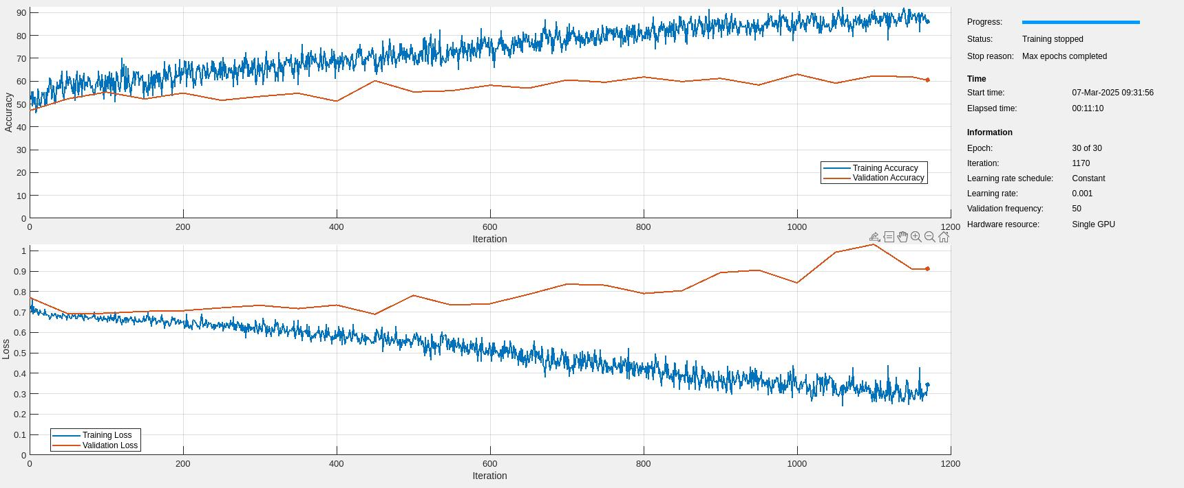
This plot is the same thing but for the second model trained on the feature extracted data. On the same hardware, it took 3.5 minutes to do the training. That is, it was nearly 3 times as fast and gave better results than the raw model.
